Click the Garageband App.
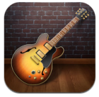
Choose either an instrument or a microphone to record either music or your voice.
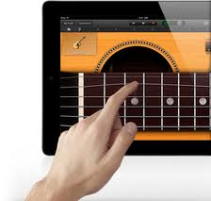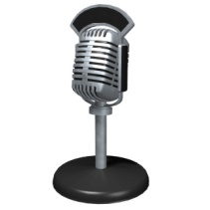
Click the puzzle piece in the top left corner.
Click “Section A” and switch “Automatic” to “ON”.
Click the red record button at the top.
Click the square to stop.

Click the bars at the top (next to the instrument/microphone) to hear your recording, then press the triangle to play.
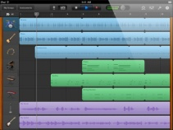
To add more music or your voice, choose “instruments” in the top left corner.
To save your podcast click “My Music” in the top left corner.
Click the title below “My Song” to type in your own title.
To upload your finished podcast to itunes, click the first box on the bottom that has an arrow coming out of it.

Click “iTunes”. Click “iTunes” again.

Type in your names under “artist” and “composer”. Type in your title under “Album Name”. Select “High Quality”. Click the blue “Share” button in the top right corner.

Save your podcast to Garageband too! To upload your finished podcast to Garageband, click the first box on the bottom that has an arrow coming out of it.
Click “iTunes”. Click “Garageband”.
You’re done!

